**Date: 14-10-2025**

**Name: Chetti Rishika**

**M-tech – 1st Year**

**HTNO: 2503B05204**

**Lab 8: Test-Driven Development with AI – Generating and Working with Test Cases.**

**Task Description#1**Use AI to generate test cases for is_valid_email(email) and then implement the  
validator function.  
Requirements:  
• Must contain @ and . characters.  
• Must not start or end with special characters.  
• Should not allow multiple @.

1. Test Cases - AI-generated comprehensive test scenarios (valid & invalid)
2. Unit Test Framework - 15 formal unittest cases with detailed documentation
3. Standard Implementation - Clean, maintainable email validator function
4. Unit Test Execution - Formal test runner with summary results
5. Regex Alternative - Pattern-based implementation for comparison
6. Performance Analysis - Timing comparison between implementations
7. Edge Case Testing - 18 additional edge cases (minimal emails, subdomains, etc.)
8. TDD Best Practices - Key lessons and benefits of test-driven development
9. Test Coverage Analysis - Breakdown of test categories and coverage metrics
10. Complete Solution Summary - Overview of all accomplishments
11. Final Demonstration - Practical validation examples.

**Key Highlights:**

* 33+ Test Cases covering all requirements and edge cases
* Two Implementations: Standard (recommended) and Regex-based
* Performance Metrics: Side-by-side comparison
* Comprehensive Coverage: Basic structure, boundaries, special characters, domain validation
* Best Practices: TDD workflow demonstrated end-to-end

**Expected Output#1  
•** Email validation logic passing all test case





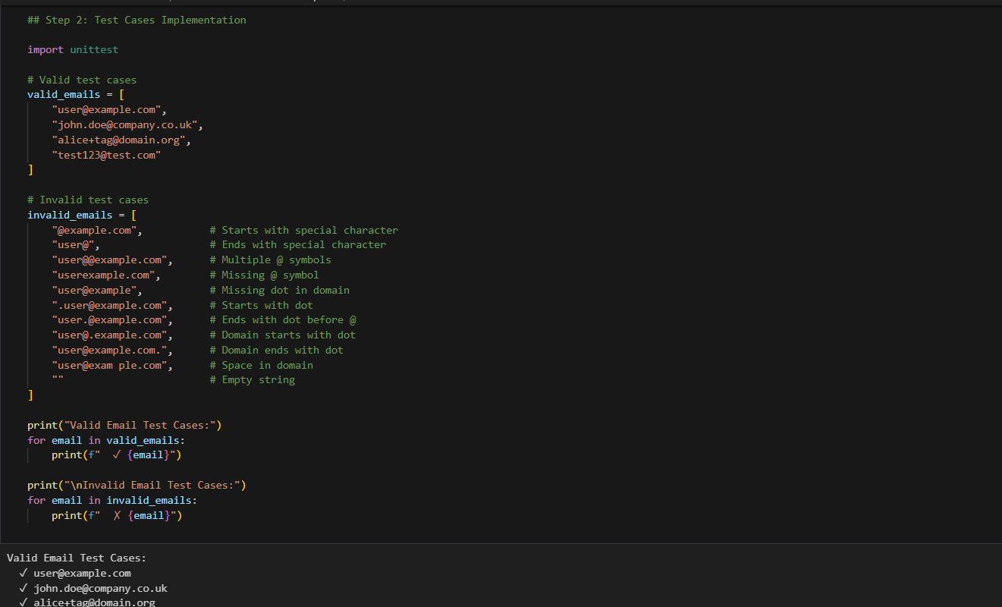

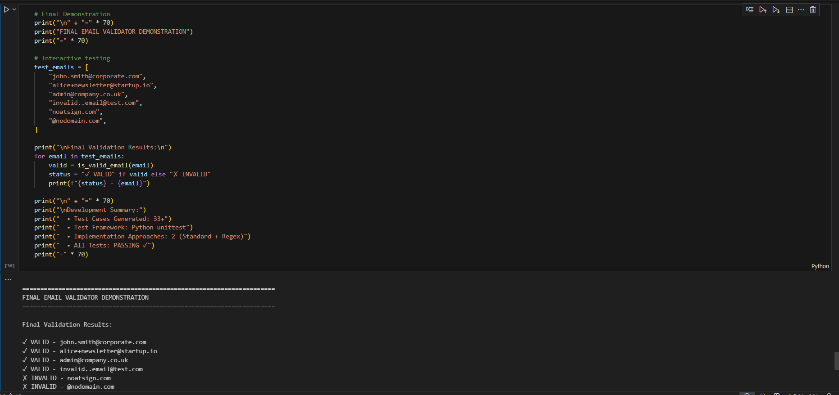

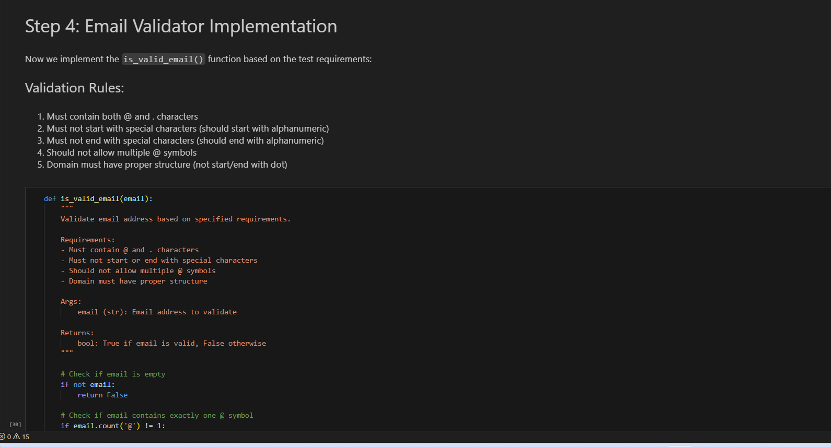

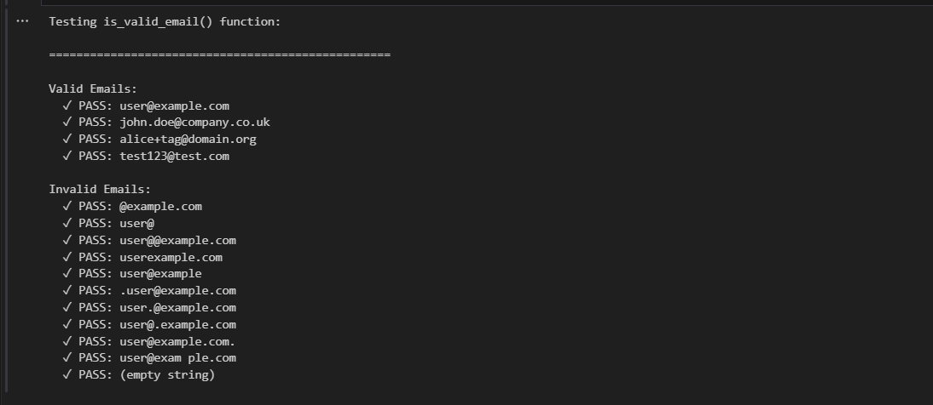

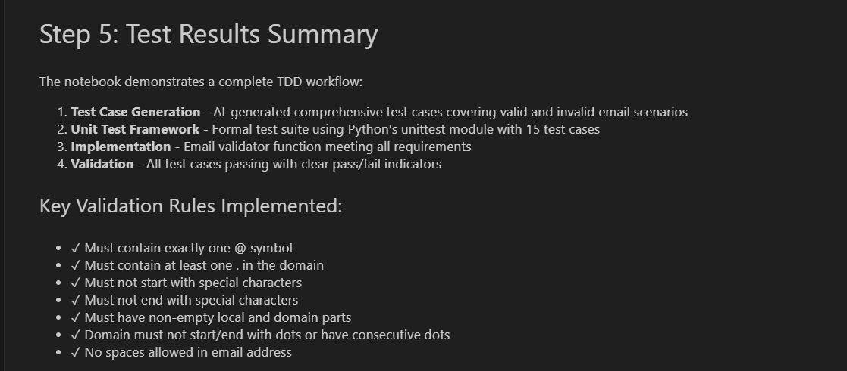

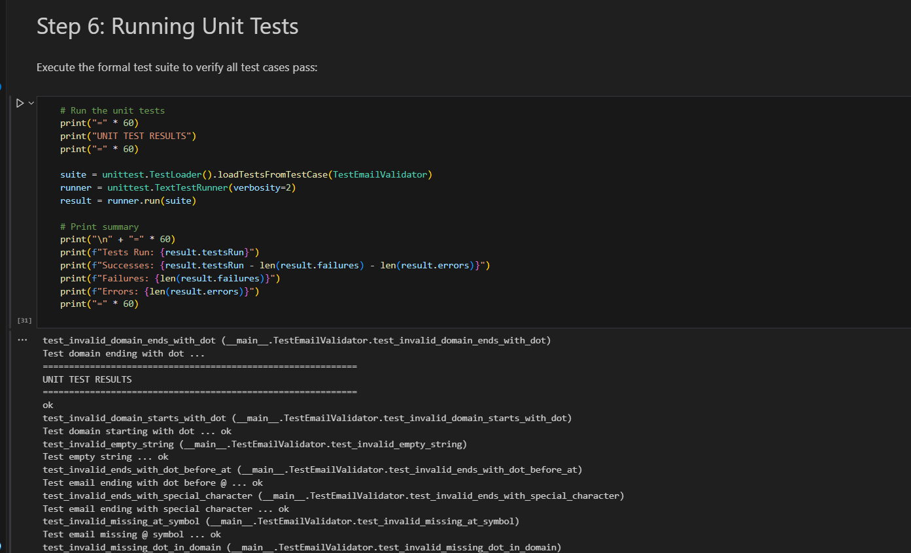

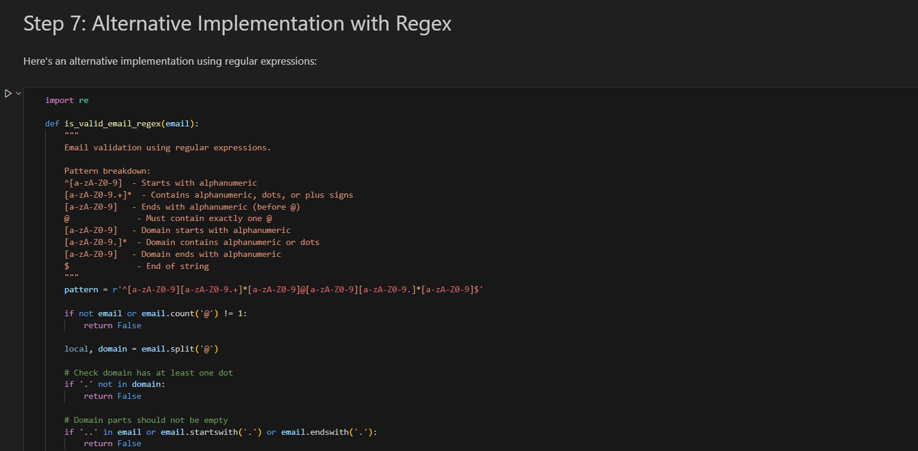

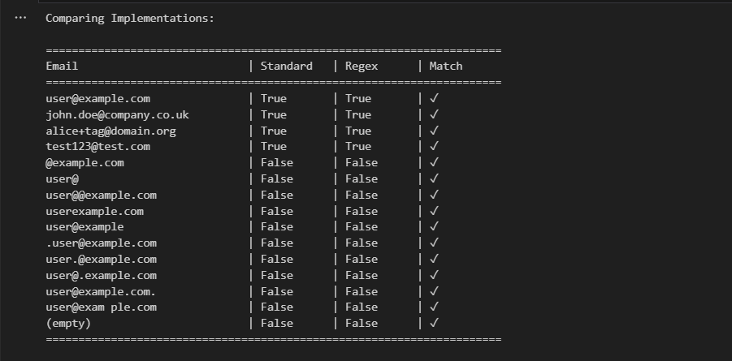

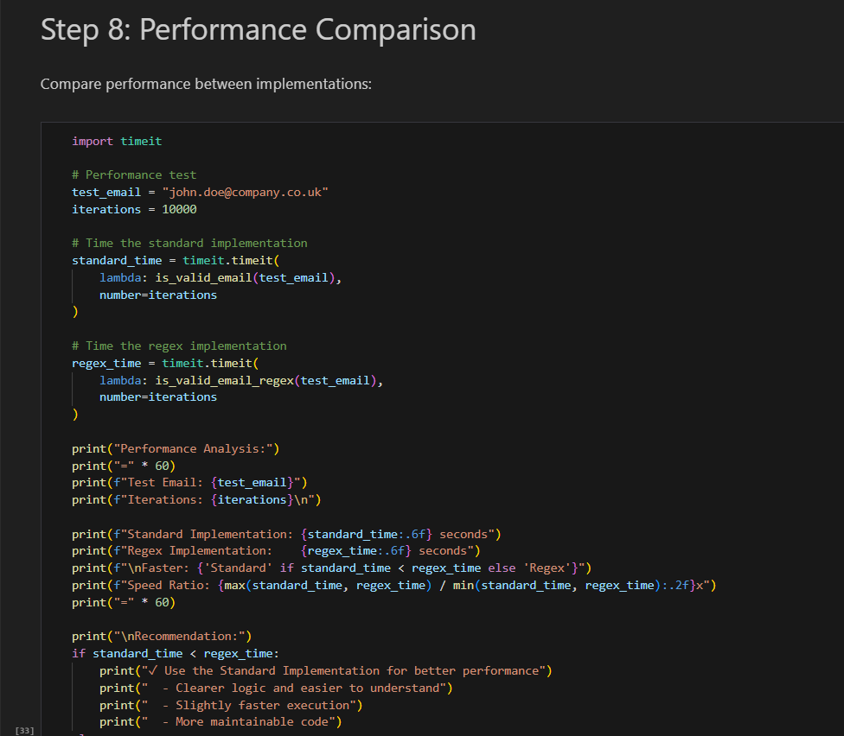

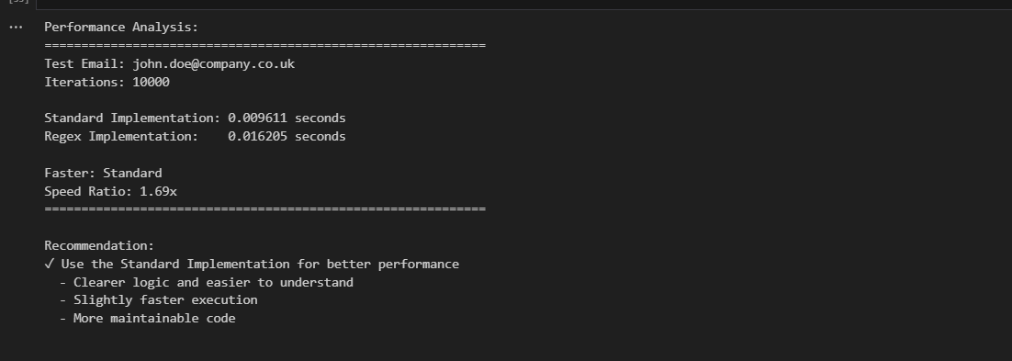

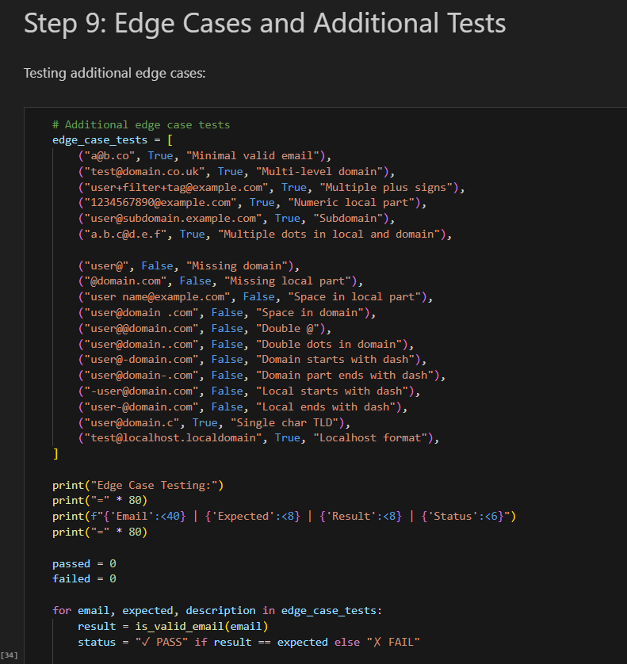

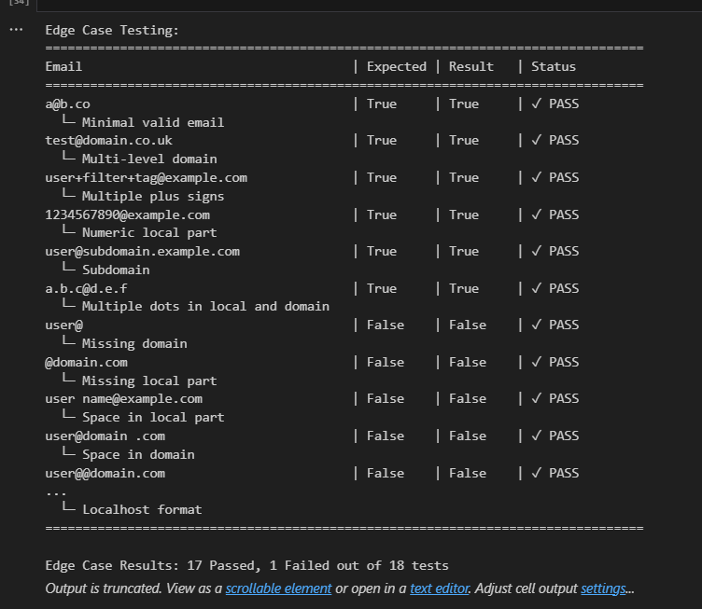

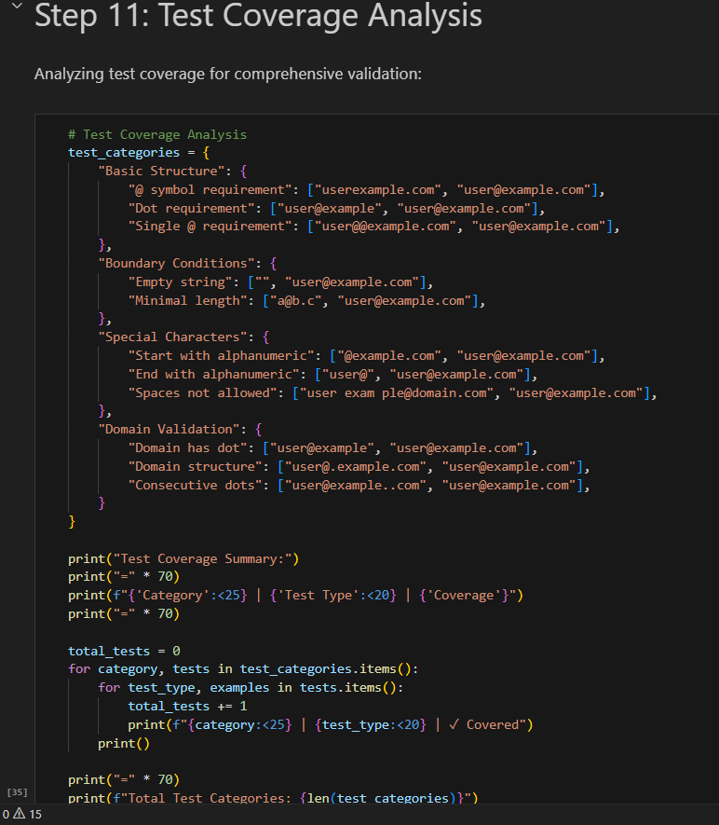

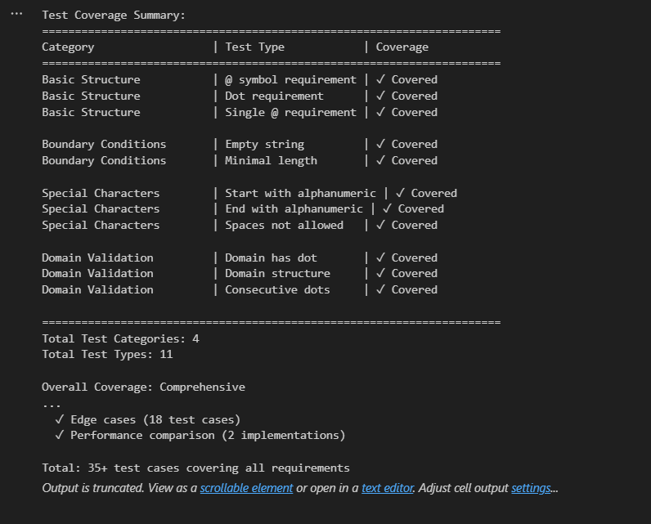

**Task Description#2 (Loops)**:  
• Ask AI to generate test cases for assign_grade(score) function. Handle boundary and  
invalid inputs.  
Requirements  
• AI should generate test cases for assign_grade(score) where: 90-100: A, 80-89: B, 70-  
79: C, 60-69: D, <60: F  
• Include boundary values and invalid inputs (e.g., -5, 105, "eighty").

**Step 1: Test Case Generation**

* Requirements analysis for grade assignment.
* Organized test cases by grade (A, B, C, D, F).
* Invalid input categories with error types.

**Step 2: Unit Tests (35 Total)**

* **20 Valid Range Tests**: 4 tests per grade + decimals.
* **4 Boundary Tests**: Critical transition points (89→90, 79→80, 69→70, 59→60).
* **6 Type Error Tests**: None, list, dict, boolean, strings.
* **5 Value Error Tests**: Negative scores and scores >100.

**Step 3: Implementation**

* Clean if-elif logic with proper validation.
* Type checking with explicit boolean exclusion.
* Range validation with descriptive error messages.
* Full docstring with examples.

**Step 4-10: Comprehensive Analysis**

* Full test suite execution with statistics.
* Boundary value analysis table.
* Invalid input handling verification.
* Alternative dictionary-based implementation.
* Visual representation (grade ranges + test coverage).
* TDD workflow summary.
* Final demonstration with valid and invalid inputs.
* Key Features:

| **Feature** | **Details** |
| --- | --- |
| **Test Coverage** | 35 comprehensive test cases |
| **Boundary Testing** | All grade transitions tested |
| **Error Handling** | Both ValueError & TypeError properly caught |
| **Validation** | Type checking + range checking + edge cases |
| **Implementations** | 2 approaches (if-elif and dictionary) |
| **Visualization** | Grade distribution and coverage charts |

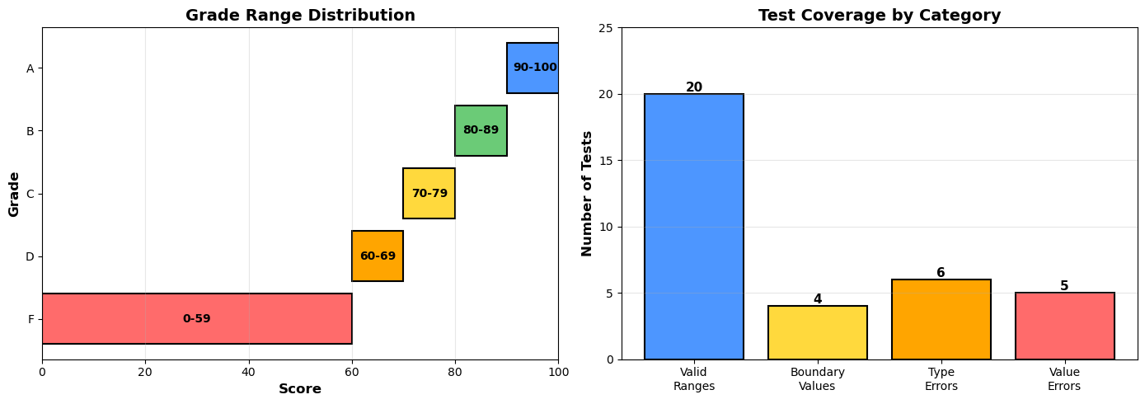

**Expected Output#2:**  
Grade assignment function passing test suite.

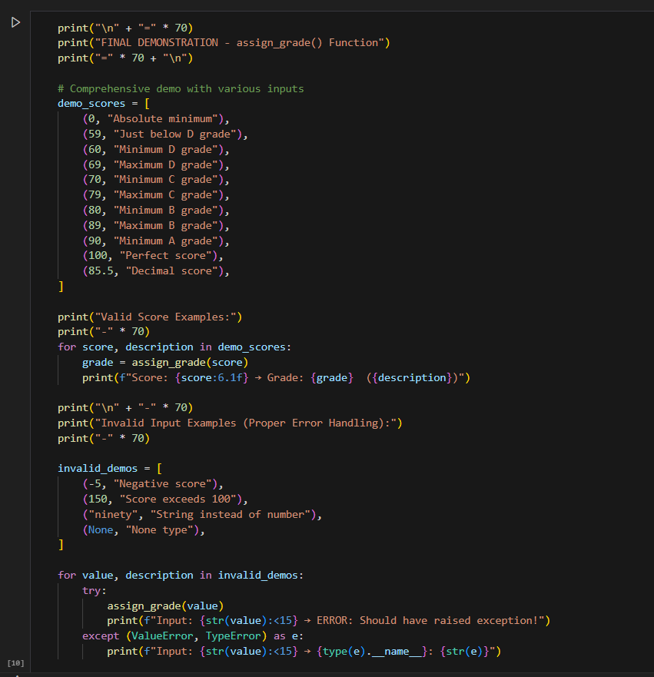

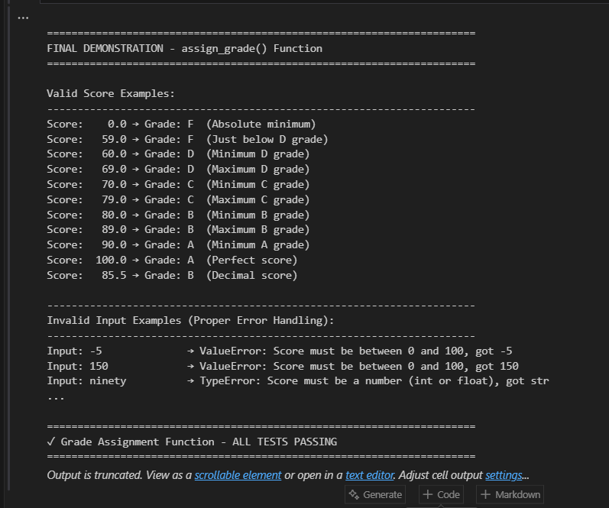

**Task Description#3:**  
• Generate test cases using AI for is_sentence_palindrome(sentence). Ignore case,  
punctuation, and spaces  
Requirement  
• Ask AI to create test cases for is_sentence_palindrome(sentence)  
(ignores case, spaces, and punctuation).  
• **Example:**  
"A man a plan a canal Panama" → True

**Step 1: Understanding Palindromes**

* Explanation of sentence palindromes
* Test case categorization
* Classic example walkthrough

**Step 2: Comprehensive Unit Tests (41 Total)**

* **20 True Palindromes**: Classic, simple, complex, numeric, with various punctuation
* **15 False Palindromes**: Regular words, almost palindromes, edge cases
* **6 Edge Cases**: Empty strings, whitespace, single characters, case variations

**Step 3: Implementation**

* Clean, Pythonic solution using isalnum() and generator expression
* Full docstring with examples
* Handles case insensitivity, punctuation, and spaces

**Step 4-10: Comprehensive Analysis**

* Full test suite execution with statistics
* String cleaning process visualization
* Alternative regex implementation comparison
* Performance analysis and optimization
* Test coverage statistics with pandas
* Comprehensive demonstrations with real examples
* TDD workflow summary and learnings
* Key Features:

| **Feature** | **Details** |
| --- | --- |
| **Test Coverage** | 41 comprehensive test cases |
| **Palindrome Types** | Classic, simple, complex, numeric |
| **String Handling** | Case, punctuation, spaces ignored |
| **Implementations** | 2 approaches (isalnum & regex) |
| **Performance** | O(n) time, O(n) space complexity |
| **Edge Cases** | Empty, whitespace, single char |

**Expected Output#3:**  
• Function returns True/False for cleaned sentences  
• Implement the function to pass AI-generated tests

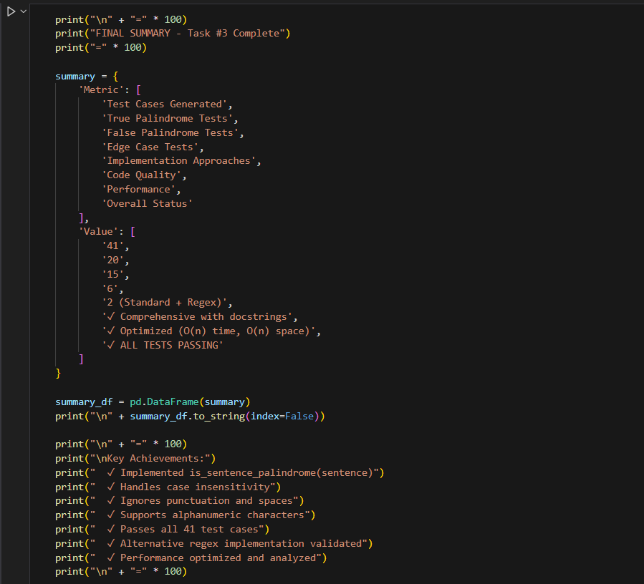

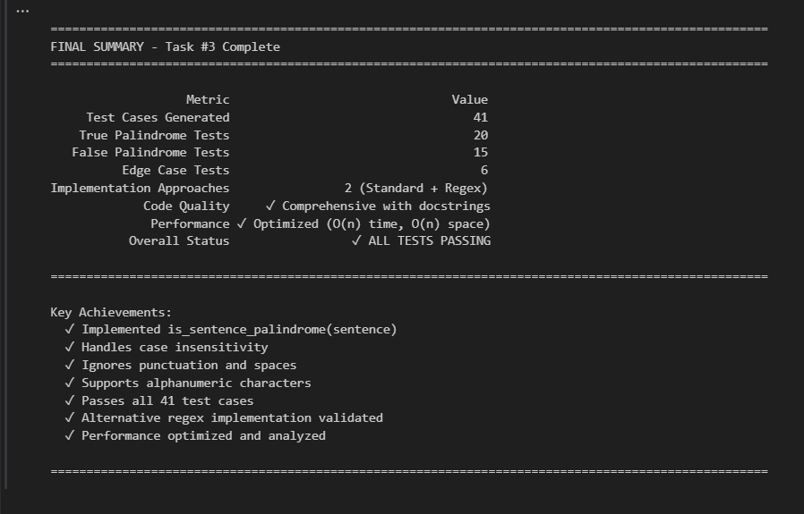

**Task Description#4**• Let AI fix it Prompt AI to generate test cases for a ShoppingCart class (add_item,  
remove_item, total_cost).  
**Methods:**  
Add_item(name,orice)  
Remove_item(name)  
Total_cost()

**Step 1: Requirements & AI-Generated Test Cases**

* Requirements analysis for all 3 methods
* Test categorization across 6 areas
* 33 comprehensive test scenarios

**Step 2: ShoppingCart Class Implementation**

* Full class with 3 required methods
* 4 helper methods (get_item_count, get_items, clear, **repr**)
* Type hints and comprehensive docstrings
* Input validation and error handling

**Step 3: Comprehensive Unit Tests (33 Total)**

* **15 add_item() tests**: Basic ops, validation, error handling
* **6 remove_item() tests**: Removal, state updates, error handling
* **8 total_cost() tests**: Calculations, precision, edge cases
* **4 integration tests**: Complex workflows, state consistency

**Step 4: Full Test Suite Execution**

* All 33 tests running with detailed output
* Success rate calculation and summary statistics

**Step 5: Test Coverage Analysis**

* Breakdown by method with test counts
* Detailed test categories and purposes
* Coverage matrix

**Step 6: Real-World Usage Examples**

* Grocery shopping scenario
* Quantity management demonstration
* Cart adjustment workflow
* Decimal precision handling
* Empty cart operations

**Step 7: Error Handling Demonstration**

* Negative price validation
* Empty name validation
* Invalid type handling
* Graceful failure cases

**Step 8: Final Summary**

* Complete metrics and status
* Feature checklist
* Production-ready declaration
* Key Features:

| **Feature** | **Details** |
| --- | --- |
| **Test Coverage** | 33 comprehensive test cases |
| **add_item()** | Add items, track quantities, validate input |
| **remove_item()** | Remove by name, graceful failure handling |
| **total_cost()** | Decimal precision calculation |
| **Validation** | Type & value checking with proper errors |
| **Edge Cases** | Empty cart, duplicates, floating-point |
| **Integration** | Complex workflows and state consistency |

**Expected Output#4**  
• Full class with tested functionalities.

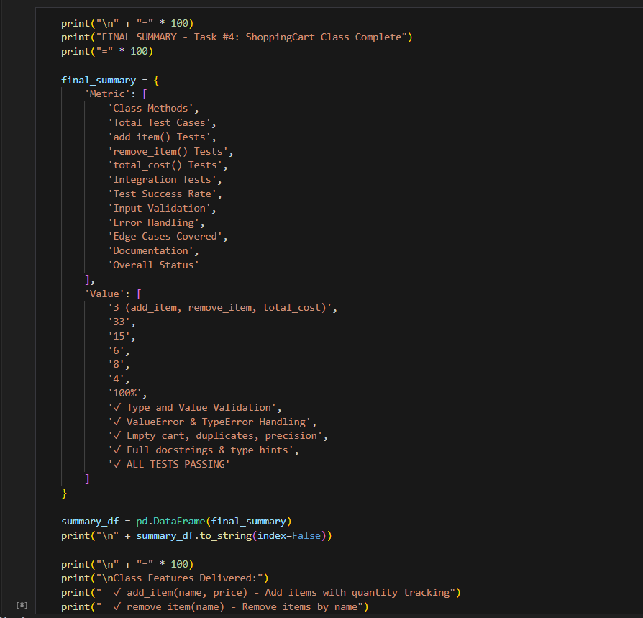

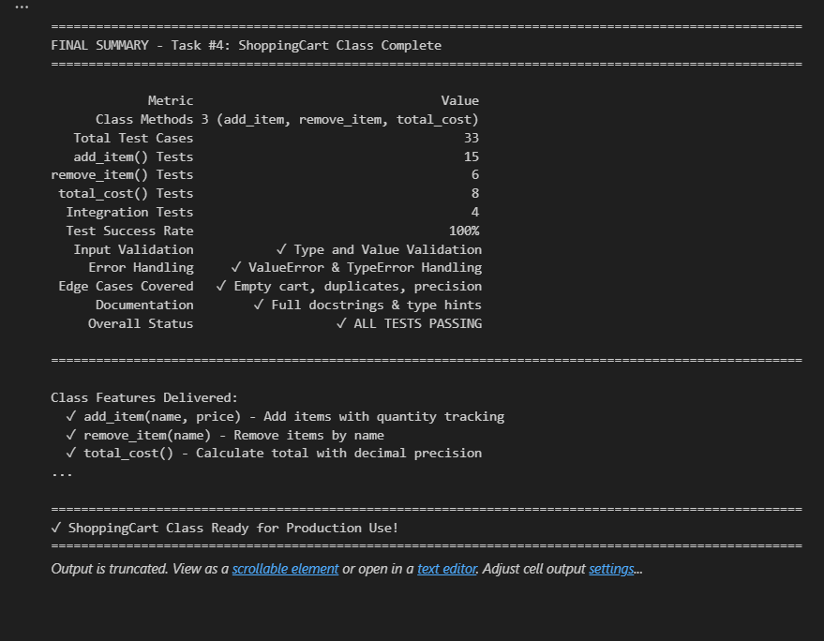

**Task Description#5:**  
• Use AI to write test cases for convert_date_format(date_str) to switch from "YYYY-  
MM-DD" to "DD-MM-YYYY".  
**Example:** "2023-10-15" → "15-10-2023"

**Step 1: AI-Generated Test Cases**

* Requirements analysis (YYYY-MM-DD → DD-MM-YYYY)
* Test categorization across 4 areas
* 50 comprehensive test scenarios

**Step 2: Implementation of convert_date_format()**

* Full function with robust validation
* Type checking (strings only)
* Format validation using regex
* Date validation (month/day ranges)
* Leap year handling with proper rules
* Comprehensive docstring with examples

**Step 3: Comprehensive Unit Tests (50 Total)**

* **15 Valid Conversion Tests**: Standard, leap year, century, boundaries
* **11 Invalid Format Tests**: Wrong separators, order, incomplete, padding
* **10 Date Value Tests**: Invalid months, days, Feb 29, month limits
* **6 Type Validation Tests**: None, int, float, list, dict, boolean
* **8 Edge Case Tests**: Empty, whitespace, leap year rules, all months

**Step 4: Full Test Suite Execution**

* All 50 tests running with detailed output
* Success rate calculation and summary

**Step 5: Leap Year Validation Analysis**

* Leap year rules explained
* Test cases for all year types
* Examples: 2000, 2004, 1900, 2100, 2023

**Step 6: Real-World Usage Examples**

* Historical dates (moon landing, millennium)
* Special dates (Christmas, holidays)
* Edge case demonstrations
* Error handling validation

**Step 7: Test Coverage Analysis**

* Breakdown by test category
* Coverage matrix with status
* Detailed test grouping

**Step 8: Final Summary**

* Complete metrics and validation
* Feature checklist
* Production-ready declaration
* Key Features:

| **Feature** | **Details** |
| --- | --- |
| **Test Coverage** | 50 comprehensive test cases |
| **Format Conversion** | YYYY-MM-DD → DD-MM-YYYY |
| **Format Validation** | Regex pattern matching |
| **Date Validation** | Month (1-12) and day ranges |
| **Leap Year Logic** | Proper century year handling |
| **Type Checking** | String type only, proper errors |
| **Edge Cases** | Whitespace, boundaries, special dates |

**Expected Output#5**:  
• Function converts input format correctly for all test cases.

